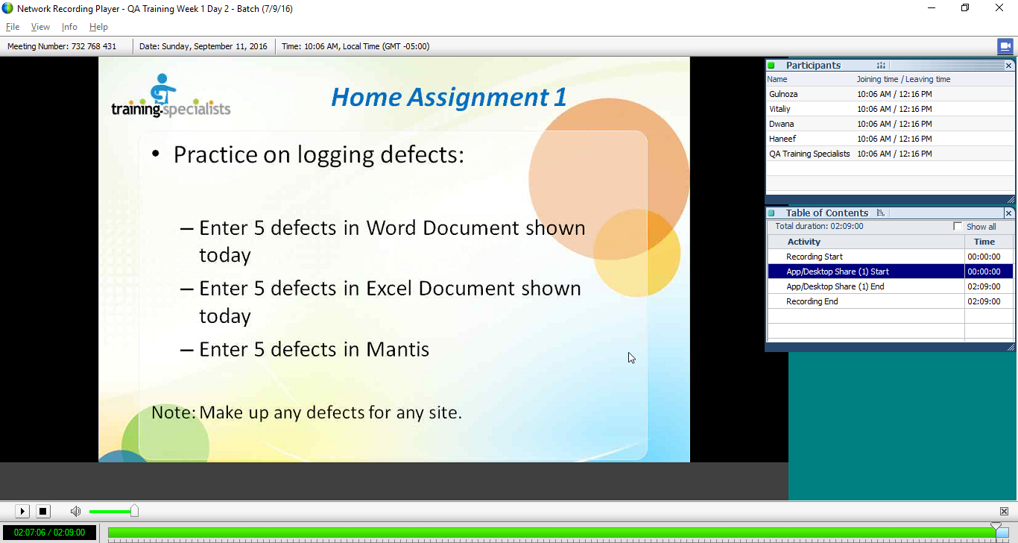

2)Pick up any topic taught and write a 2-3 pgs explanation about it.